Social media posts with graphics.
Copy and Paste à Use these sample messages and graphics when communicating via Facebook, Twitter, Instagram, or other social platforms.
Please note: These social media images are licensed for this purpose only. Please do not use them
to create other materials.
Tag Us à Facebook: @PSEG Twitter: @PSEGDelivers Instagram: @PSEG
Graphic | Message
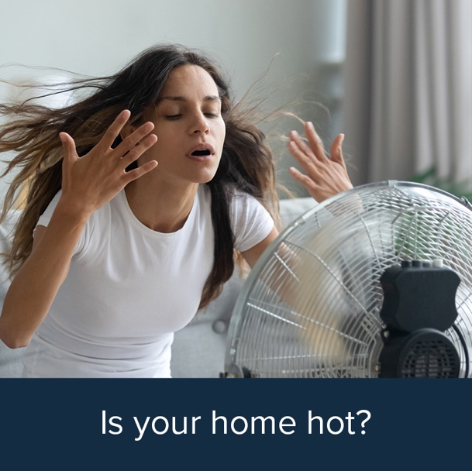 | Is your home hot? PSE&G can help you figure out why. See if  you are eligible for PSE&G’s Home Weatherization Program for Income-Qualified Customers and up to $7,500 in energy  efficiency, health, and safety upgrades.  Learn more: https://bit.ly/PSEGPrograms  #PSEGCommunityAlly #BeCool
 | Is your home drafty? You may qualify for no-cost weatherization help from PSE&G. Home upgrades can include insulation in walls, ceilings, and attic.  Learn more: https://bit.ly/PSEGPrograms  #PSEGCommunityAlly #SaveMoney

Graphic | Message
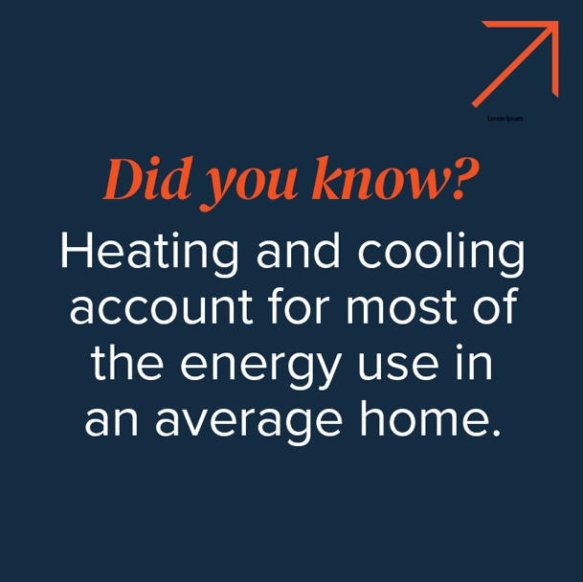 | #DYK heating and cooling account for most of the energy use in an average home?  See if you are eligible to receive a free energy assessment—and  up to $7,500 in energy efficiency, health, and safety upgrades at  no cost.  Learn more: https://bit.ly/PSEGPrograms  #PSEGCommunityAlly #StayCool
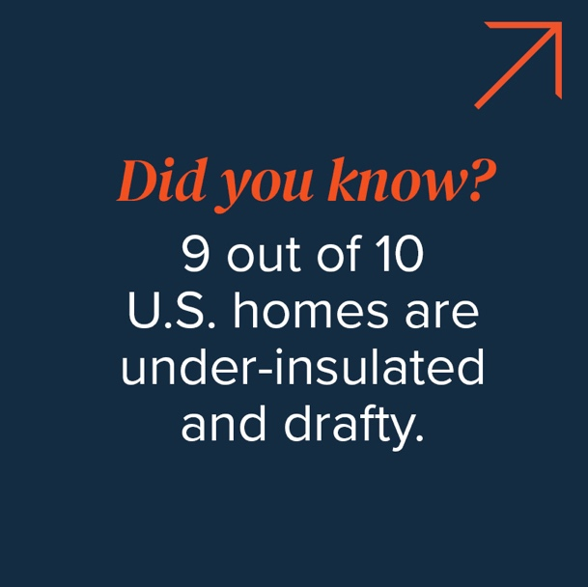 | #DYK nine out of 10 U.S. homes are under-insulated and drafty?  You may qualify for no-cost weatherization help from PSE&G. Save money and keep your home safe, healthy, and comfortable!  Learn more: https://bit.ly/PSEGPrograms  #PSEGCommunityAlly

Graphic | Message
 | Celebrate getting the most out of every dollar you spend on energy. PSE&G rebates and services can help you  use less energy and save money.  Learn more: https://bit.ly/PSEGHomeEnergy  #PSEGCommunityAlly #Dance
 | Expecting guests? Keep your home cool in summer, warm in winter, and comfortable all year.  See if you are eligible for a free energy assessment and up to $7,500 in energy efficiency, health, and safety upgrades—such  as heating and cooling equipment tune-ups—at no charge.  Learn more: https://bit.ly/PSEGPrograms  #PSEGCommunityAlly #Friends

Graphic | Message
 | As you plan for your future, know that PSE&G residential energy efficiency programs can save you money and energy.  See if you are eligible to receive a free energy assessment to pinpoint energy-saving opportunities—as well as up to $7,500 in energy efficiency, health, and safety upgrades at no cost.  Learn more: https://bit.ly/PSEGPrograms  #PSEGCommunityAlly #BrightFuture
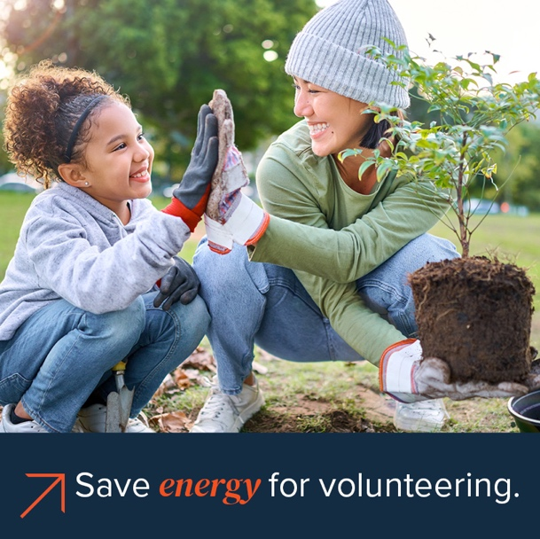 | Save energy and time for volunteering. Let a certified energy adviser identify where your home might be wasting energy. See if you qualify for a free energy assessment and up to $7,500 in energy efficiency, health, and safety upgrades.  Learn more: https://bit.ly/PSEGPrograms  #PSEGCommunityAlly #Volunteer

Graphic | Message
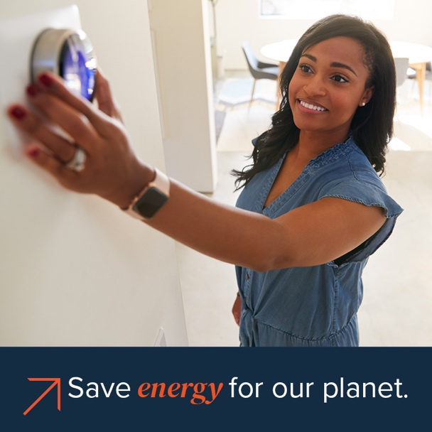 | #EnergyEfficiency helps lower carbon emissions by reducing the amount of energy we consume. Adjusting your energy habits at home is easy. Turn off lights, unplug electronics, and get free expert advice on improving your home’s energy efficiency from PSE&G.  Get started today: https://bit.ly/PSEGHomeEnergy  #PSEGCommunityAlly
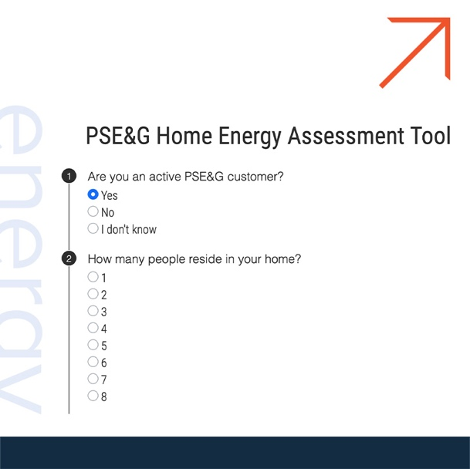 | A home energy assessment is a simple way to get the most out of every dollar you spend on energy. Use the PSE&G Home Energy Assessment Tool to find out which home energy assessment is right for you.  Learn more:  https://bit.ly/PSEGHomeEnergyAssessments  #PSEGCommunityAlly

